Montessori Soccer
In our classes, children will have fun learning…
- Ball control skills
- Passing
- Finishing
- Dribbling
- Receiving
- Heading
- Defense
- Sportsmanship
Weekly Soccer for PreKindergarten and Younger:
$60.00 Initial Registration (Includes shirt to wear on soccer days and soccer bag)
($50.00 Annual Re-registration)
$50.00 per month, 45 minute classes
- Strap-on SHIN GUARDS are mandatory for all players
Weekly Soccer for Kindergarten – 5th Grade:
$60.00 Initial Registration (Includes shirt to wear on soccer days and soccer bag)
($50.00 Annual Re-registration)
$60.00 per month, 1 hour classes
- SHIN GUARDS are mandatory, strap-on for Kindergartners
- Cleats can be worn, 3rd – 5th Grade Only
Additional shirts $15.00 / bags $20.00
Soccer Registration Form
Please return this form to school office:

Student Name(s): _____________________
_____________________
Payment Amount: $__________
Please refer to rates on inside of brochure.
Please include check, cash or money order payable to the school or check below:
Please check here to pay Initial Registration and monthly tuition by Tuition Express.
Although Montessori Academies /Preparatory Schools and instructors take measures to ensure the safety of all students, the possibility for injury does still exist. I understand that any athletic activity involves the possibility of injury. I assume all responsibility for any injury occurring during normal participation during soccer clinics offered by Montessori Academies/Preparatory Schools and coaches. I have read and agree to all rules and policies regarding fees and attendance for participation in the soccer clinics being offered at the Montessori Academies/Preparatory Schools.

x_________________________ Date: _______
(Parent/Guardian’s Signature)

x________________________
(Parent/Guardian’s Name – PLEASE PRINT)

Your signature represents an open-ended enrollment. If you wish to discontinue for any reason, you must notify the school in writing. Re-registration fees will apply should you wish to restart.

BENEFITS OF PLAYING SOCCER
Promotes cognitive development
Friendly competition creates motivation and drive
Improves gross motor skills
Increases positive social interactions
Improves concentration and focus
Strengthens core muscles
Improves cardiovascular health
Boosts self-confidence and self-esteem
Improves work ethics and develops responsibility
Develops Leadership skills and how to work as a team
The fast pace of soccer makes children think and respond quickly
0
“Success is no accident. It is hard work, perseverance, learning, studying, sacrifice and most of all, love of what you are doing or learning to do.” –Pele

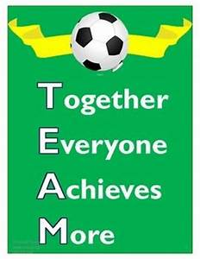

“I’ve never scored a goal in my life without getting a pass from someone else.” - Abby Wambach
Montessori Academies

After School
Soccer Program

Administered by coaches:
Claude “Jeff” Baptiste
and
Brent “BG” Cartagena

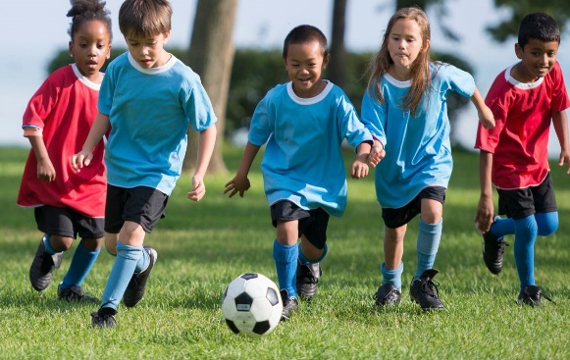

“Do you know what my favorite part of the game is? The opportunity to PLAY!”

